**ASSIGNMENT 1:**

**Module 2: Basic Python Concepts**

**Task 1: Perform Basic Mathematical Operations**

**Problem Statement: Write a Python program that does the following:**

**1.** **Takes two numbers as input from the user.**

**2.** **Performs the basic mathematical operations on these two numbers:**

o **Addition**

o **Subtraction**

o **Multiplication**

o **Division**

**3.** **Displays the results of each operation on the screen.**

**Expected Output:  
The output should include the result of each operation performed, for example:**

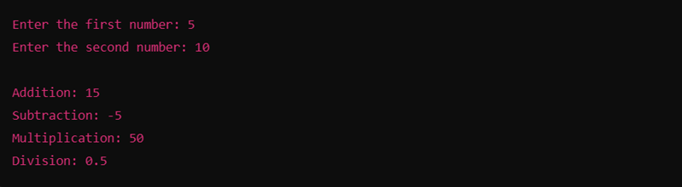

**Task 2: Create a Personalized Greeting**

**Problem Statement:** Write a Python program that:

1. Takes a user's first name and last name as input.

2. Concatenates the first name and last name into a full name.

3. Prints a personalized greeting message using the full name.

**Expected Output:**The program should output a greeting like:

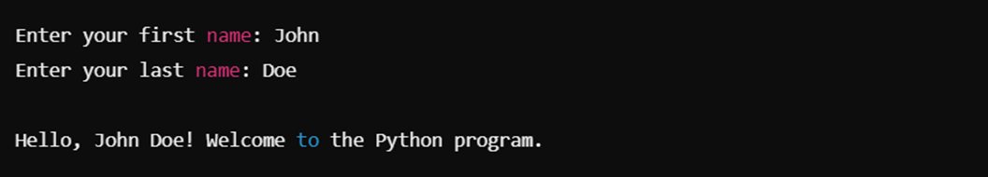

**Submission Instructions:**

* Please watch the following video and follow the steps shown in it to complete your assignment: **Video Link:** [Click Here](https://drive.google.com/file/d/1W7zBA-jT-4hc-pmCEpHLMEO6GipFXPv5/view?usp=sharing&utm_source=chatgpt.com)

<https://drive.google.com/file/d/1W7zBA-jT-4hc-pmCEpHLMEO6GipFXPv5/view>

* Create a **GitHub repository** and upload your Python scripts (.py files).
* Ensure the repository includes a **README.md** file that describes the functionality of your programs.
* Add both **Task 1 and Task 2** scripts in the same repository.
* Submit the **link to your GitHub repository** once uploaded.

**Reference:**

Follow the **Python course - Module 2: Basic Python Concepts** for additional guidelines and examples.

**Note: Please test your project thoroughly and check all the validations and error handling prior to ensure it works as expected before submission.**

**You can always connect to the mentor using the chat support option for any doubts or queries!**